## How to Enable External Sharing Settings for SharePoint Online Site:

Go to O365 SharePoint Admin Portal -> Under Active sites -> Search the site in which you want to activate External Sharing -> Select the site click on three dots and select Sharing option.

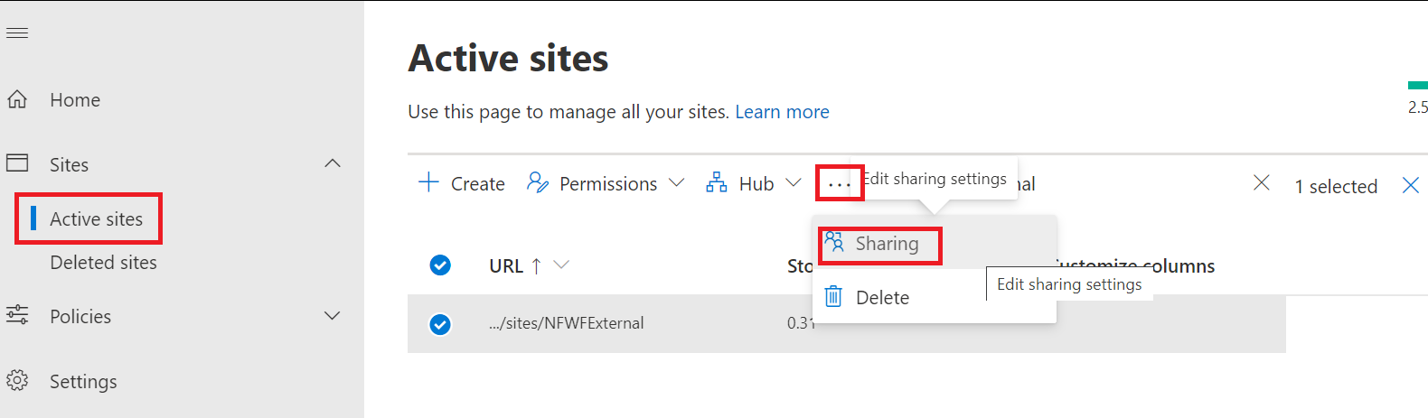

Under External Sharing Select

* “Anyone” option to provide permissions to External users to access the Public link without Sign in.
* “New and Existing guests” - option send an email to authorize External user to provide credentials to access the link has been Shared with you.
* “Existing Guests Only” - Only those External Users are able to access the link who are already added into Organization directory previously for another site.
* “Only People in Your Organization” – No External Sharing is allowed.

In our Scenario we are allowing Anyone, as we are sharing Public link without Login.

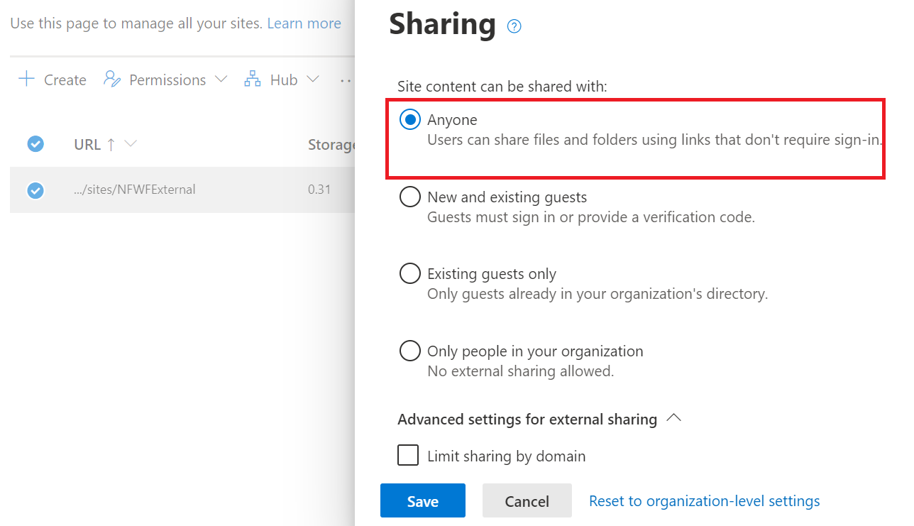

Click on Save Button to do the Changes.

You can now be able to share the file link with Anyone providing Public link:

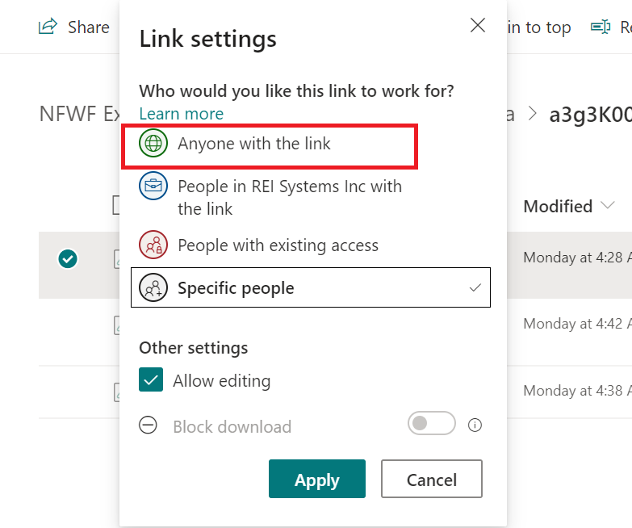

If you do not want to Allow External Users to Edit the file, please uncheck “Allow editing”.

---------------------- END -----------------------